Ht202570 Use Maps on your iPhone iPad or iPod touch

Use Maps to get directions with real-time traffic information, explore and find new places, and more.

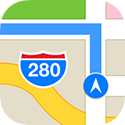

With iOS 10, Maps makes things even easier to find by giving you detailed information and suggestions based on your habits and calendar events.

Get started
When you tap the Search bar, Maps shows you categories for nearby locations, like restaurants and coffee shops. When you tap a category, Maps provides nearby suggestions. To browse the suggestions, swipe up on the menu bar.
Depending on your carrier and cellular data plan, cellular data charges might apply when using Maps.

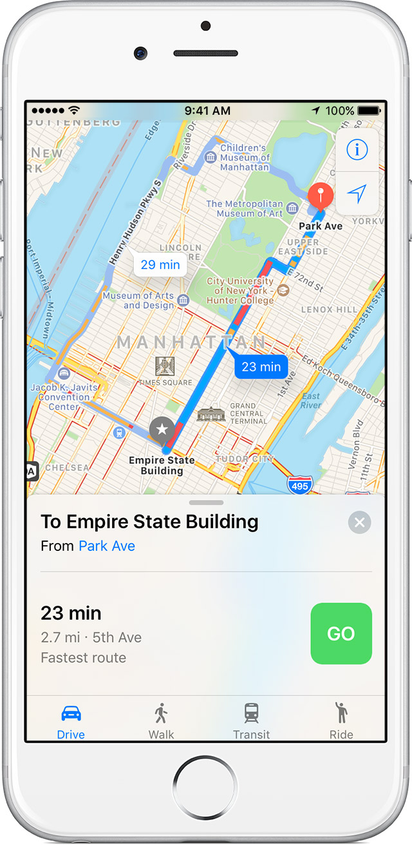
Get directions
- Open Maps and enter your destination in the Search bar.
- Tap Directions.
- Choose Drive, Walk, Transit, or Ride.
- Select the route that you prefer. Maps shows the fastest route first based on traffic conditions.
- When you're ready, tap .
- To end navigation, tap , in the bottom-right corner. Then tap End Route.
When you start moving, Maps updates its position to give you a better sense of direction. You can also use your finger to scroll ahead to see any obstructions on your route.

Use a Marker to get directions between two locations
You can use markers to mark your current location. You can also drop a marker to show the distance from one location to another.
To mark a location:
- Tap  in the upper-right corner of Maps.
- Then tap Mark My Location. You can also touch and hold your finger on a specific area to mark its location.
To get directions between two locations other than your current location:
- Tap a landmark icon or drop a marker.
- Tap Directions, then tap My Location.
- To change your start point, tap the text bar. You can also tap  to swap your start and end points.
- Tap Route. Maps will show you the fastest route.
To remove a marker, tap the marker, tap Edit Location, then tap Remove Marker.

Avoid tolls and highways, and see traffic in your area
To avoid tolls and highways, go to Settings > Maps > Driving & Navigation. Then tap the sliders for Tolls or Highways.
If there's traffic in the area, you'll see these colors:
- Orange lines show traffic
- Red lines show heavy traffic
You might also see markers for road closures 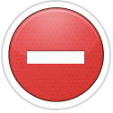, construction 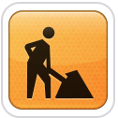, and accidents 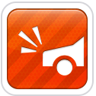.

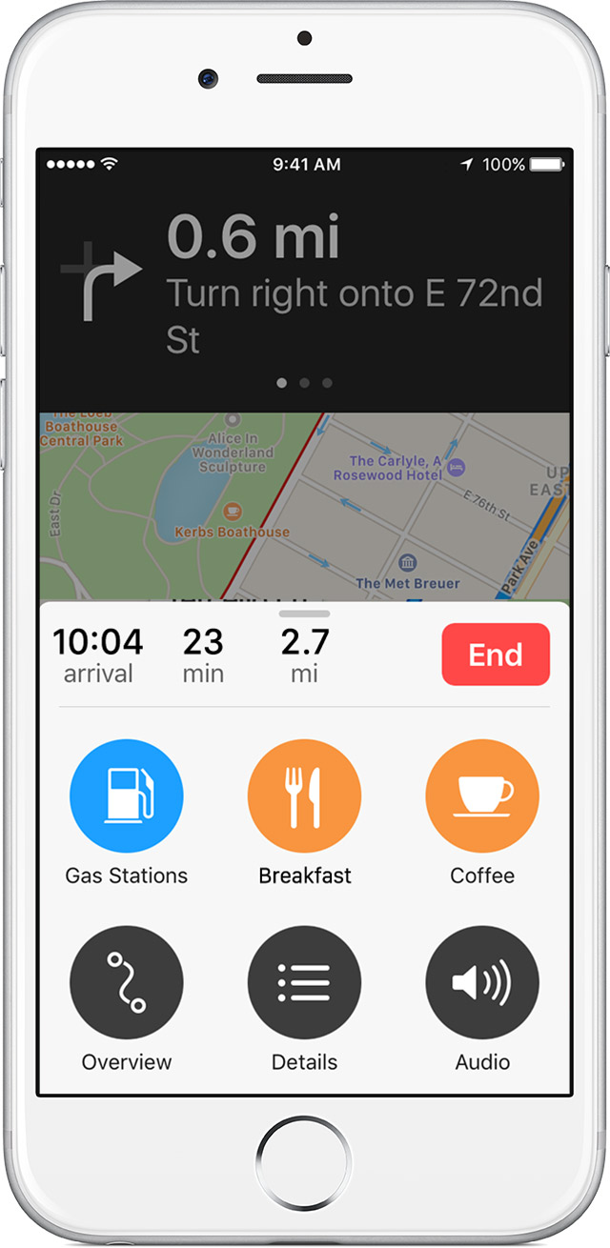
Use the Route Card
With iOS 10, you can use the Route Card to find nearby places, like gas stations, food, and more.
To add a detour to a trip, follow these steps:
- Swipe up on the menu bar while you're navigating.
- Select an option, like Gas Stations. Maps will show you a list of nearby suggestions.
- Tap . Maps will add the detour to your original route.
- When you’re ready, tap the blue banner at the top of the screen to resume your route.
To get detailed turn-by-turn directions, swipe up on the menu while you're navigating and tap Details. You can also see your trip overview and adjust your Navigation Voice settings from the same menu bar.
Selecting the output will determine where Navigation Voice will play the turn-by-turn directions.¹ If you’re using Maps connected to Bluetooth, like in your car, you can choose how to get these directions. Learn how to use Maps with Bluetooth.

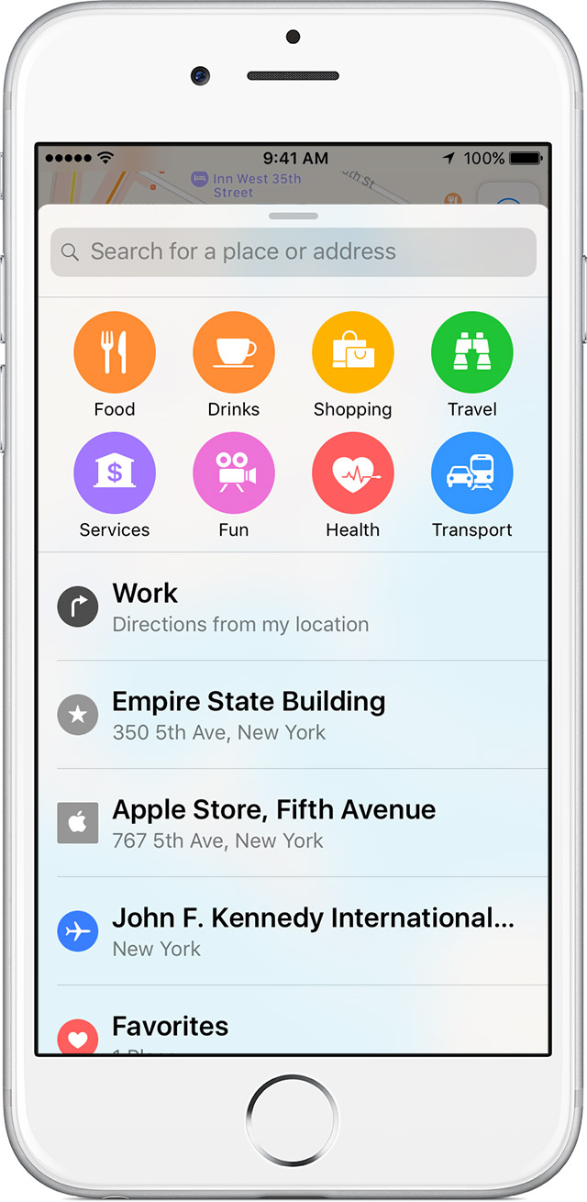
Search for places nearby
With iOS 9 and later, you can use Nearby to search for things that are near your location, like food and entertainment.
To find nearby places, follow these steps:
- Open Maps.
- Tap the Search bar to see the categories in your area.
- Select a category, then choose a location.
- After you choose a location, tap Directions.
- Tap .
Find out if Nearby is available in your area.

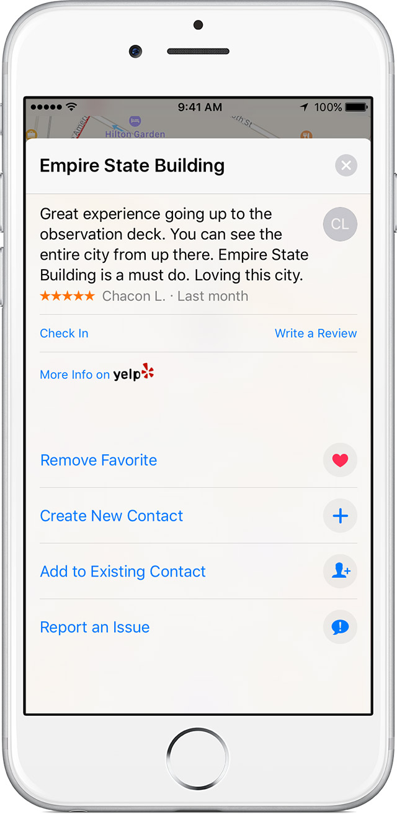
Add or remove your favorite locations
To add a location to your Favorites, follow these steps:
- Select a location.
- Scroll to the bottom of the screen.
- Tap Add to Favorites.
To share, edit, or remove a favorite, follow these steps:
- Tap the Search bar.
- Scroll down and tap Favorites.
- Swipe left over the favorite, then tap Share or Remove.

Clear your history
- Open Maps.
- Swipe up on the menu bar to open the Search card.
- Swipe left on a previous destination.
- Tap Remove.

Add a favorite transit line
With iOS 10, you can add transit lines to your Favorites, and then see them in your Widget for timely information. To add a transit line to your favorites, follow these steps:
- In Maps, tap , then select Transit.
- Zoom in on the transit line. Then tap the name or number of the transit line. You might also see a symbol for the transit line.
- When you see the Details card, scroll to the bottom and tap Add to Favorites.
You can also enter your destination, then tap Directions to see if there are any other types of transit that you can take.

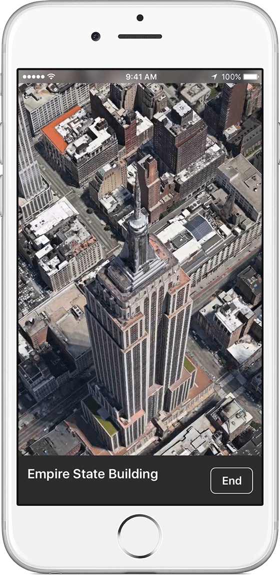
Use Flyover Tour and 3D Maps
With 3D and Flyover Tour,² you can see interactive 3D views of cities and landmarks.
To get a 3D view, follow these steps:
- Pinch to zoom in on a city on the map.
- Place two fingers side by side on the map, then drag up.
- To exit, tap .
To take a Flyover Tour, follow these steps:
- Enter the name of the city in the Search bar and tap the city in the results.
- Tap Flyover Tour.
- To exit, tap .
Find out if 3D Maps and Flyover Tour are available in your area.

Learn more
- Learn how to use Maps and Bluetooth on your iPhone or iPad.
- Report an issue with Maps if you can't see your location or notice incorrect results.
- Use Maps to find your parked car on your iPhone.

- Turn-by-turn navigation works on iPhone 4s or later, iPad Pro, iPad Air or later, iPad 2 or later, and iPad mini or later with cellular data capability.
- Flyover Tour is available on iPhone 4s or later, iPad Pro, iPad Air or later, iPad 2 or later, iPad mini or later, and iPod touch (5th generation or later). Cellular data charges may apply.

Encourage customers to use Report an Issue whenever possible. Customers who report an issue have these options:
- Search results are incorrect
- Street or other label is incorrect
- Location is missing
- Problem with directions
- My problem isn't listed
If a customer reports issues with incorrect locations, icons, or routing, tell them to go to Settings > Maps and turn on Follow up by Email. Available only with iOS 9, Follow up by Email allows Apple to reach out to the customer for more information if they report an issue with Maps.
Information about products not manufactured by Apple, or independent websites not controlled or tested by Apple, is provided without recommendation or endorsement. Apple assumes no responsibility with regard to the selection, performance, or use of third-party websites or products. Apple makes no representations regarding third-party website accuracy or reliability. Risks are inherent in the use of the Internet. Contact the vendor for additional information. Other company and product names may be trademarks of their respective owners.
Helpful?
Yes No
Article:
HT202570
Last Modified:
Yesterday
Radar Number:
21859301, 22761798 View >
Open tickets in radar

Related
How To
Use Notes on your iPhone, iPad, and iPod touch Get help connecting your iPhone, iPad, or iPod touch with your car stereo Help customers use a specific Bluetooth profile on their iPhone, iPad, or iPod touch Use Continuity to connect your Mac, iPhone, iPad, iPod touch, and Apple Watch Get help with Maps Use the Maps app to help find your destination If the screen on your iPhone, iPad, or iPod touch doesn't respond to touch Get public transit directions in Maps on your Mac Keeping iPhone, iPad, and iPod touch within acceptable operating temperatures

