Ht202860 Change or reset the password of a macOS user account

You can change the password that you use to log in to your Mac, or reset the password if you don't remember it.


The password of your macOS user account is also known as your login password. It's the password that you use to log in to your Mac and make certain changes, such as installing software.
Change your password
If you know your password and can use it to log in to your account, you can change your password in Users & Groups preferences:
- Choose System Preferences from the Apple menu, then click Users & Groups.
- Select your user name from the list of users.
- Click the Change Password button, then follow the onscreen instructions. If you're using a password hint, remember to update the hint for your new password.

Reset your password
If you don't remember your password, or it isn't working, you might be able to reset it using one of the methods described below. But first try these simpler solutions:
- Make sure that you're typing the correct uppercase or lowercase characters. If your keyboard has Caps Lock turned on, the password field shows a Caps Lock symbol .
- If the password field shows a question mark, click it to display a password hint that might help you to remember.
- Try to log in without a password. If that works, you can then add a password by following the steps to change your password.
- Try to log in with the Apple ID password that you use for iCloud. If you just changed that password and the new password isn't working, try the old password first. If that works, you should be able to use the new password from then on.
Reset using your Apple ID
In some macOS versions, you can use your Apple ID to reset your login password. At the login screen, keep entering a password until you see a message saying that you can reset your password using Apple ID. If you don't see the message after three attempts, your account isn't set up to allow resetting with Apple ID.
- Click the arrow next to the Apple ID message, then follow the onscreen instructions to enter your Apple ID and create a new password. You'll be asked to restart when done.
- Log in with your new password.
- Create a new login keychain.
Reset using another admin account
If you know the name and password of an admin account on your Mac, you can use that account to reset the password.
- Log in with the name and password of the other admin account.
- Choose System Preferences from the Apple menu, then click Users & Groups.
- Click the Lock button , then enter the admin name and password again.
- Select your user name from the list of users.
- Click the Reset Password button, then follow the onscreen instructions to create a new password:
- 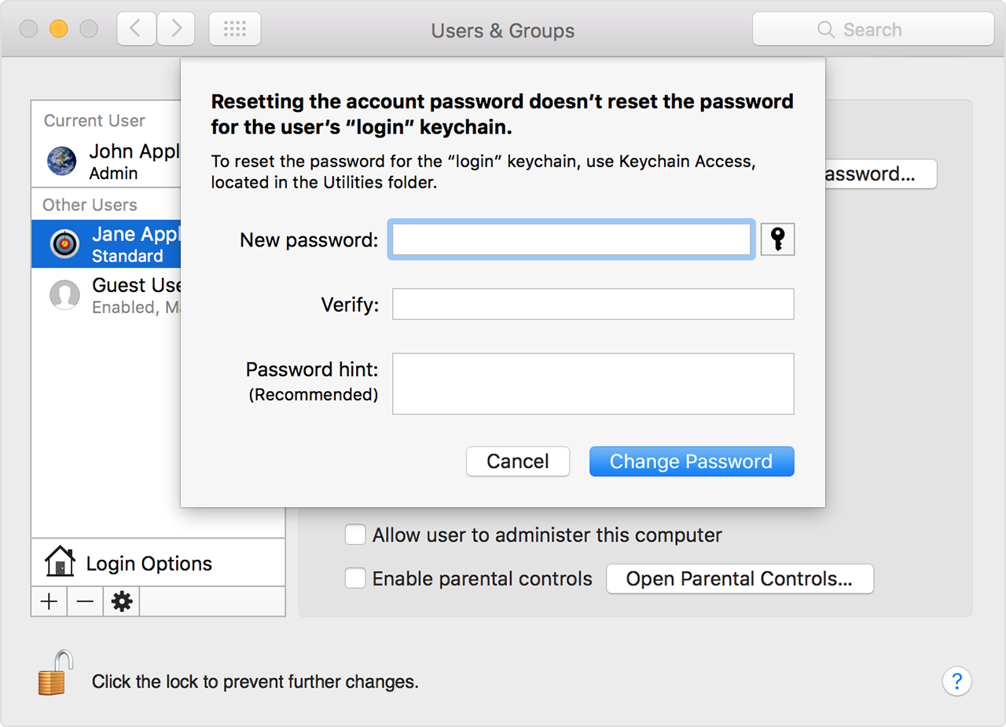
- Choose Log Out from the Apple menu.
- Log in to your account using your new password.
- Create a new login keychain.
Reset using the Reset Password assistant (FileVault must be on)
If FileVault is turned on, you might be able to reset your password using the Reset Password assistant:
- Wait up to a minute at the login screen, until you see a message saying that you can use the power button on your Mac to shut down and start up again in Recovery OS. If you don't see this message, FileVault isn't on.
- Press and hold the power button until your Mac turns off.
- Press the power button again to turn on your Mac.
- When the Reset Password window appears, follow the onscreen instructions to create a new password.
- If you need to connect to Wi-Fi, move your pointer to the top of the screen and use the Wi-Fi menu  to connect. To exit without resetting your password, choose Apple menu > Restart. 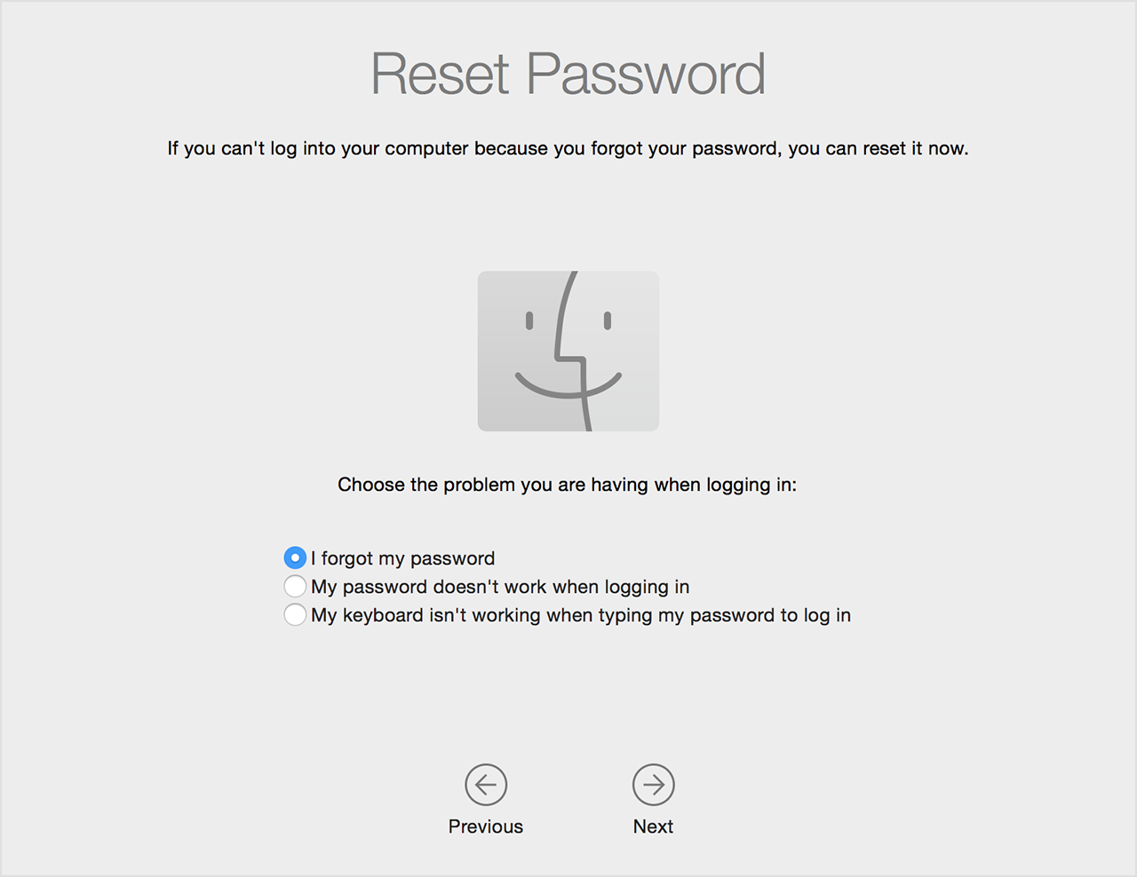
- When done, click Restart.
- If you were able to reset your password with the Reset Password assistant, log in to your account using your new password.
- Create a new login keychain.
Reset using your Recovery Key (FileVault must be on)
If FileVault is turned on and you have a FileVault Recovery Key, you can use that key to reset your password.
- At the login screen, keep entering a password until you see a message saying that you can reset your password using your Recovery Key. If you don't see the message after three attempts, FileVault isn't on.
- Click the arrow next to the message. The password field changes to a Recovery Key field.
- Enter your Recovery Key, then follow the onscreen instructions to create a new password. Click Reset Password when done.
- Create a new login keychain.

Create a new login keychain
After resetting your password and logging back in to your account, you might see an alert that the system was unable to unlock your login keychain. This is expected, because the passwords for your user account and login keychain no longer match. Just click the Create New Keychain button.
If you didn't see an alert about your login keychain, or you see other messages asking for your old password, reset your keychain manually:
- Open Keychain Access, which is in the Utilities folder of your Applications folder.
- Choose Preferences from the Keychain Access menu, then click the Reset My Default Keychain button in the preferences window. After you enter your new password, Keychain Access creates an empty login keychain with no password. Click OK to confirm.

- If you don't see a Reset My Default keychain button, close the preferences window and select the “login” keychain from the left side of the Keychain Access window. Press the Delete key, then click Delete References.

- Choose Log Out from the Apple menu to return to the login screen.
- Log in to your account using your new password. Your account password and login keychain password now match again.

If you still can't log in
If you still can't log in with your password, contact Apple Support for help.
If the user can't log in with their iCloud password
If the customer just changed their iCloud password at appleid.apple.com, ask them to log in with their old password. If that works, they'll be prompted to enter their new iCloud password as well. After entering the new iCloud password, they should be able to log out and log back in using the new iCloud password.
If that doesn't work, try these steps:
- Disable access to the Internet.
  - If using an Ethernet connection, disconnect the Ethernet cable.
  - If using a Wi-Fi connection, temporarily power off the Wi-Fi router, or move the Mac out of network range.
- While still disconnected from the Internet, restart the Mac and log in with whatever password was last used successfully.
- After logging in, reconnect the Mac to the Internet.
- Open iCloud preferences, sign out of iCloud, then sign back in.
If that doesn't work, follow the steps for resetting the password using another admin account. If there is no other admin account, create one as follows:
- Start up in single-user mode.
  - If you're using FileVault, release the keys when you see the login window. Then log in to continue startup in single-user mode.
  - If you're using a firmware password, you must turn off the password before you can start up in single-user mode.
- After the scrolling text stops, enter these three commands, one at a time:

- mount -uw /
- rm /var/db/.AppleSetupDone
- reboot

- After entering the reboot command, the Mac restarts and the setup assistant appears. Use the setup assistant to create a new admin account that is different from the customer's existing account.
- You should now be able to follow the steps for resetting the password using the new admin account.
macOS Sierra
When you start up from the macOS Sierra Recovery partition and enter "resetpassword" in Terminal, the screens that appear depend on whether FileVault is enabled or not.
If FileVault is enabled, the screens shown will be the same as the screens shown in the public section of this article under "Reset using the Reset Password assistant (FileVault must be on)" and under the "Reset Password assistant screens" in the internal section of this article.
If FileVault isn't enabled, Reset Password will display the following screens:
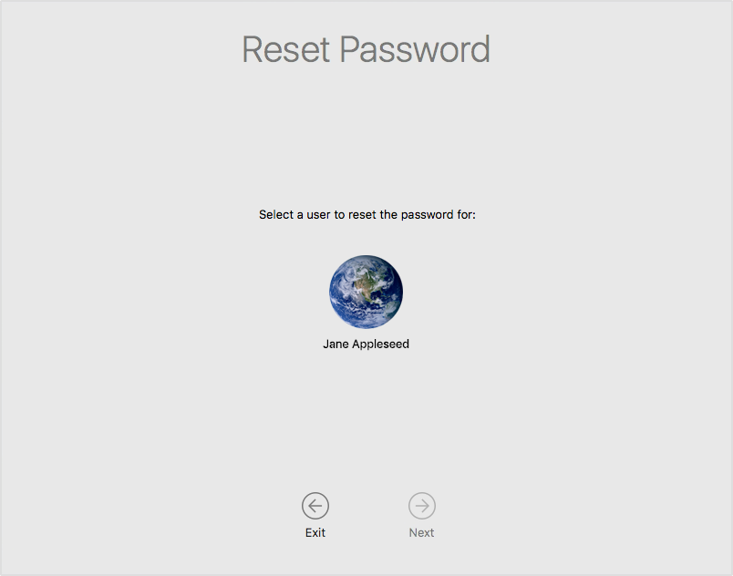
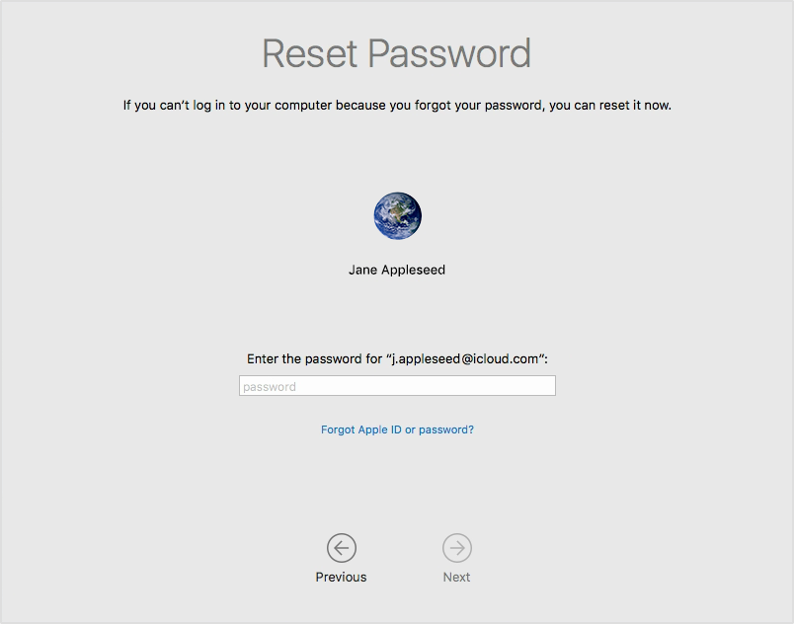
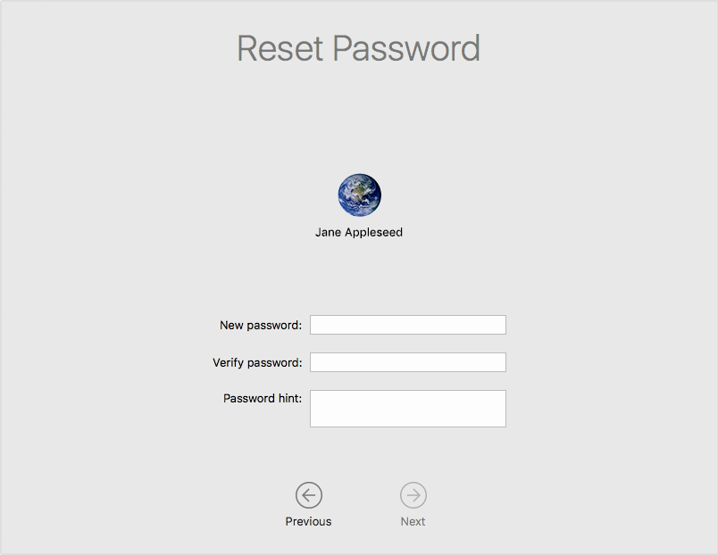
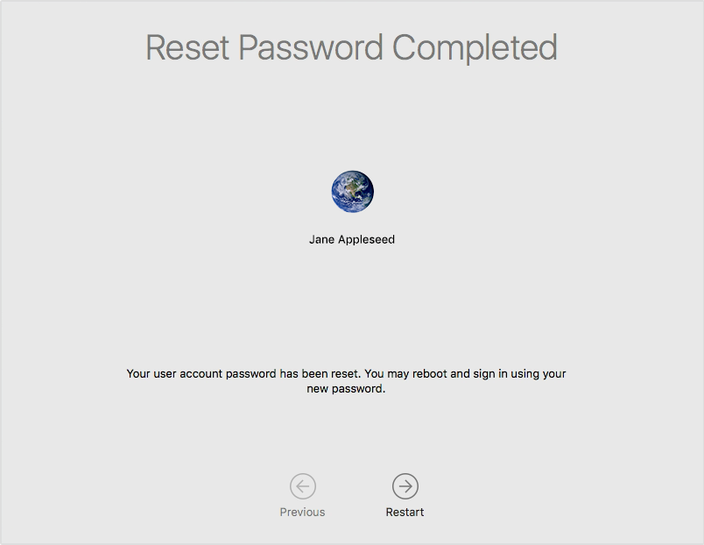
Reset based on the FileVault option that was selected (FileVault must be on) - OS X Lion v10.7 or later
The available methods to reset the password depend on which option was selected when FileVault was turned on.
If the “Store the recovery key with Apple” option was selected in OS X Lion v10.7 to OS X Mavericks v10.9:
Look up the customer's Recovery Key in iLog. The customer might not be sure if they selected this option when they turned on FileVault. Or they might not know how to locate the Record Number that iLog requests. In these cases, complete these steps:
- Restart the computer to get to the FileVault login screen.
- Select a user, if more than one is shown.
- In the Enter Password field, click the question mark or enter an incorrect password three times in a row.
- Click the button next to “reset it using your Recovery Key.”
- In the Recovery Key field, click the question mark.
If the recovery key was stored by Apple, the Serial Number and Record Number of the Mac display. If the recovery key wasn't stored with Apple, "Type the recovery key" displays. The Serial Number and Record Number aren't shown.
If the “Allow my iCloud account to unlock my disk” option was selected in OS X Yosemite v10.10 or later:
Follow the steps in Reset using the Reset Password assistant (FileVault must be on). Select the option "I forgot my password.” If "Allow my iCloud account to unlock my disk" wasn’t selected when FileVault was turned on, the Reset Password assistant displays "You do not have iCloud FileVault recovery setup for this volume.”
If neither option was selected:
- Restart the computer to get to the FileVault login screen.
- Select a user, if more than one is shown.
- In the Enter Password field, click the question mark or enter an incorrect password three times in a row.
- Click the button next to “reset it using your Recovery Key.”
- Enter the Recovery Key that displayed when FileVault was turned on.
Customers who don’t know the Recovery Key must erase their startup disk. Guide them through the steps in How to reinstall macOS under "If you can't reinstall because you can't turn off FileVault.”
Reset using the Reset Password Utility (FileVault must be off) - OS X Lion v10.7 to OS X El Capitan v10.11
If the previous solutions don't work, use the Reset Password Utility to reset the password of the user's admin account.
- In OS X Lion v10.7 to OS X El Capitan v10.11:
  - Start from OS X Recovery.
  - Choose Utilities > Terminal, then enter the resetpassword command.
- In Mac OS X Snow Leopard v10.6 and earlier:
  - Start from the Mac OS X Install disc.
  - Choose Utilities > Reset Password.
- The Reset Password Utility window should appear. Complete all fields and menus, then click Save.
- If you can't select the volume containing the user's account, FileVault is turned on. In that case, follow the steps for using the Reset Password assistant instead.
- 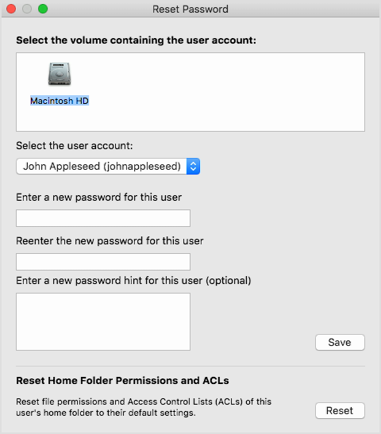
- When you see the Login Password Reset alert, click OK.
- Restart the Mac, then log in with the new password.
- Create a new login keychain.
Reset from single-user mode (FileVault must be off)
If the previous solutions don't work, use single-user mode to reset the password of the user's admin account.
macOS Sierra, El Capitan, Yosemite, Mavericks, Mountain Lion, Lion
- Start the Mac in single-user mode.
- Open Terminal, then enter this command:

- mount -uw /

- In macOS Sierra, El Capitan or Yosemite, separately enter both of these commands:

- launchctl load /System/Library/LaunchDaemons/com.apple.taskgated.plist

- launchctl load /System/Library/LaunchDaemons/com.apple.opendirectoryd.plist

- In Mavericks, Mountain Lion, or Lion, enter just this command:

- launchctl load /System/Library/LaunchDaemons/com.apple.opendirectoryd.plist

- If you don't know the user's short name, enter this command to get a list of users, with shortnames on the left and full names on the right:

- dscl localonly ls /Local/Default/Users realname

- Enter this command, replacing shortname with the admin user's short name (the name of their home folder):

- passwd shortname

- Enter the new account password when prompted. You might not see any indication that you're typing.
- Enter the reboot command to restart the Mac.
Snow Leopard
- Start the Mac in single-user mode.
- Open Terminal, then enter this command:

- mount -uw /

- If you don't know the user's short name, enter this command to get a list of short names:

- ls /Users

- Enter this command:

- launchctl load /System/Library/LaunchDaemons/com.apple.DirectoryServices.plist

- Enter this command, replacing shortname with the user's short name (the name of their home folder):

- passwd shortname

- Enter the new account password when prompted. You might not see any indication that you're typing.
- Enter the reboot command to restart the Mac.
Reset Password assistant screens - OS X Lion v10.7 to macOS Sierra
Refer to these screens as a visual aid when using the Reset Password assistant.
1. Choose your langauge.
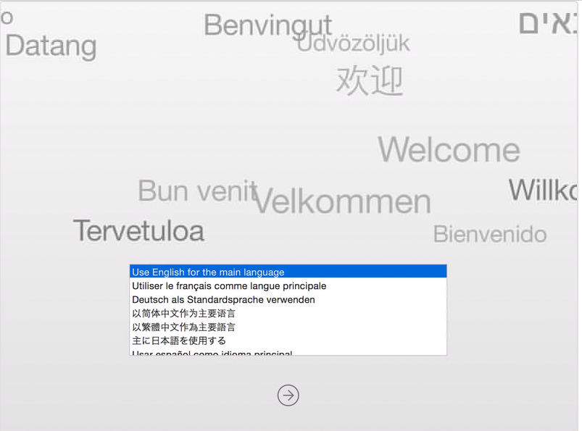
2. Choose the problem you are having when logging in.
1. I forgot my password.
1. Select a user to reset the password for.
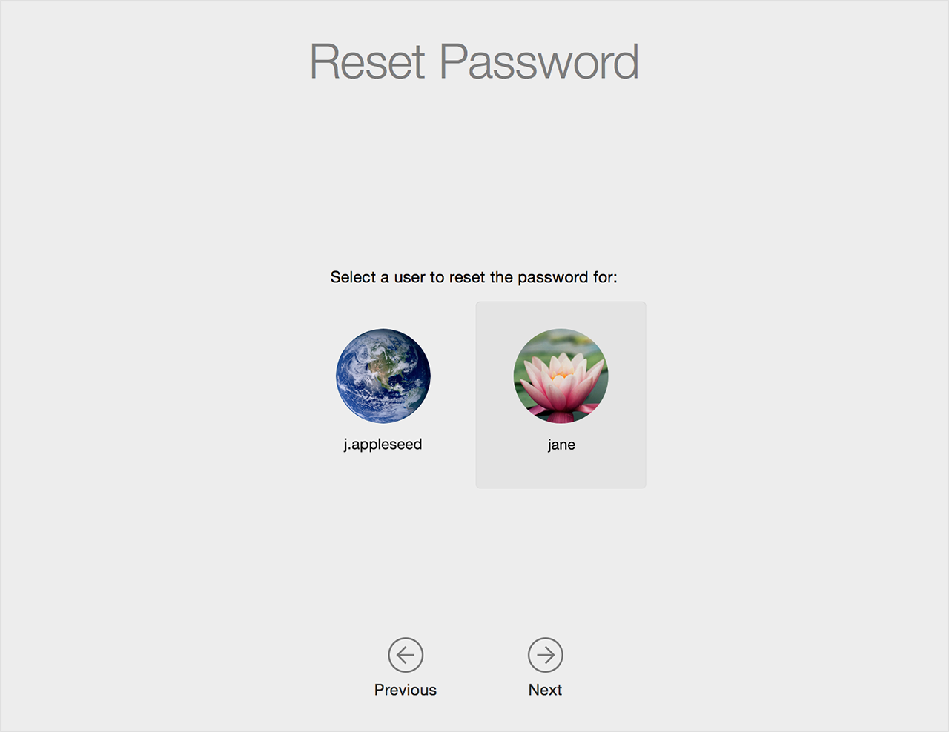
2. Sign in with your Apple ID.
(If the user enters the wrong name or password, the operation is denied.)
If you get a connection error, the Mac's clock may be set to the wrong date. To check this, complete the steps in the "If you get a connection error" section.
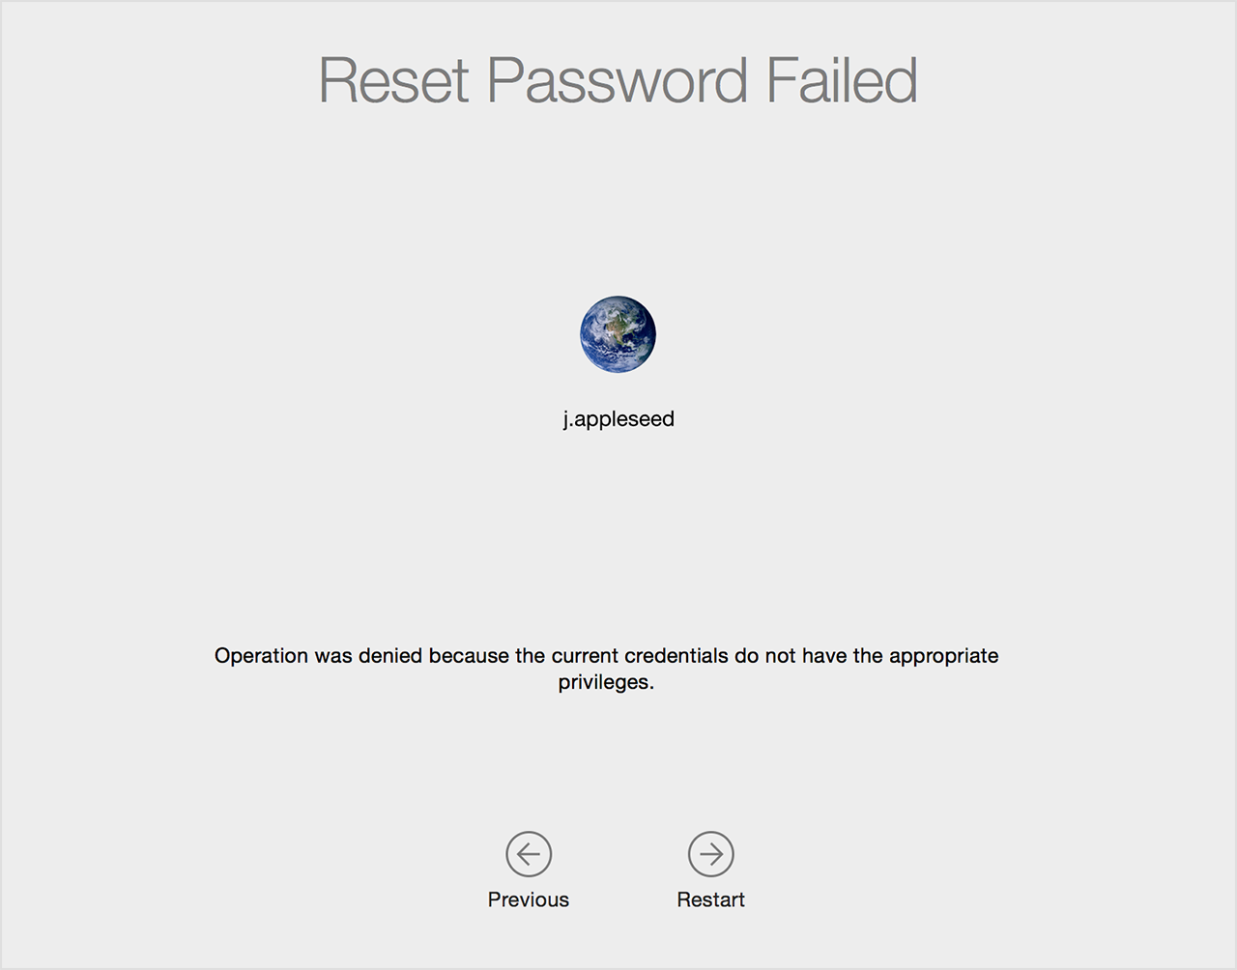
2. My password doesn't work when logging in.
1. Enter your password to unlock the volume:
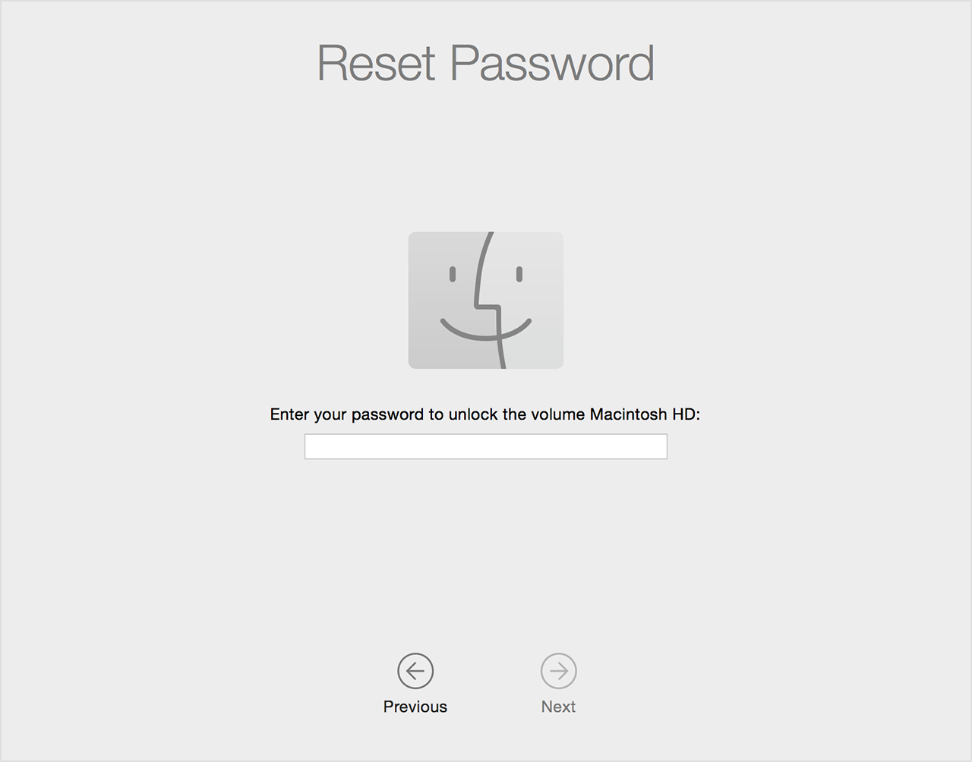
2. Select a user to reset the password for.

3. Change your password. Don't use complex or accented characters.
(If the password was never linked to iCloud or Apple ID during FileVault setup, the user is told that they don't have iCloud FileVault recovery set up for this volume.)
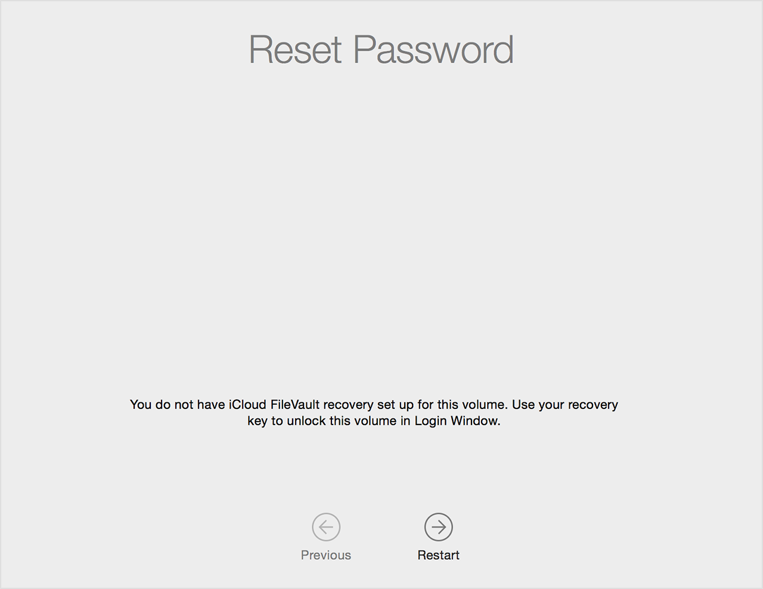
3. My keyboard isn't working when typing my password to log in.
• Enter your password to disable FileVault
(The user must know their password.)
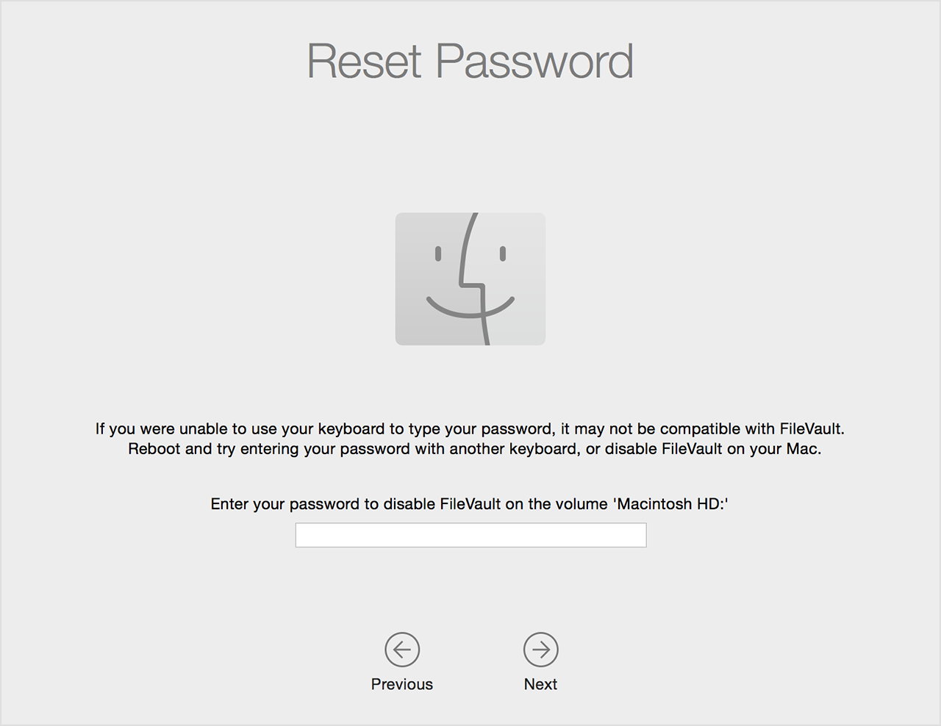
If you get a connection error
If you get a connection error message while using the I forgot my password option in the Reset Password assistant, the date on your Mac might be incorrect. You can use the Recovery partition to correct this by following these steps:
- After you start up from the Recovery partition, in the Utilities menu, select Terminal.
- In the Terminal window, type "date" and press Return. This will display the date and time that the clock on your Mac is set to.
- If the date or time that displayed in the previous step is incorrect, enter this command to correct it:
date mmddHHMMyy
Replace the letters after "date" with numbers, as follows:

mm = Numeric month, a number from 1 to 12.
dd = Day, a number from 1 to 31.
HH = Hour, a number from 0 to 23.
MM = Minutes, a number from 0 to 59.
yy = Year in abbreviated form (e.g., 89 for 1989, 06 for 2006).
For example, to set the date time to March 10, 2016 18:05, the command entered would be:
date 0310180516
Helpful?
Yes No
Article:
HT202860
Last Modified:
05/24/2017
Radar Number:
31876643, 27727855, 22945067, 22692243, 21567452, 19185022, 18893545, 31843704, 31876643 View >
Open tickets in radar
Affected Products:
Mac OS X 10.6,OS X El Capitan,OS X Lion,OS X Mavericks,OS X Mountain Lion,OS X Yosemite

Related
How To
Change the name of your macOS user account and home folder Recently published KB articles OS X: Apple ID can be used to reset your user account password If your Mac keeps asking for the login keychain password If you forgot your Apple ID password Change your Apple ID password iCloud: Change your iCloud password If Time Machine can’t change destination disks or Wi-Fi login doesn't retain password for next login Change the language used at the login screen on your Mac

