HT204926 Turn on iCloud Music Library

When iCloud Music Library is turned on, you can access your entire music collection across your iPhone, iPad, or iPod touch, Mac, or PC.

With your Apple Music membership, you can access your music library on all of your devices as long as you're signed in to all of your devices with the same Apple ID and iCloud Music Library is turned on.
Apple Music features and content varies by country and region.
Turn on iCloud Music Library
Make sure that you're signed in to all of your devices with the Apple ID that you use for your Apple Music membership. Then follow these steps to turn on iCloud Music Library.
On your iPhone, iPad, or iPod touch
- Go to Settings > Music, and tap iCloud Music Library to turn it on.
- 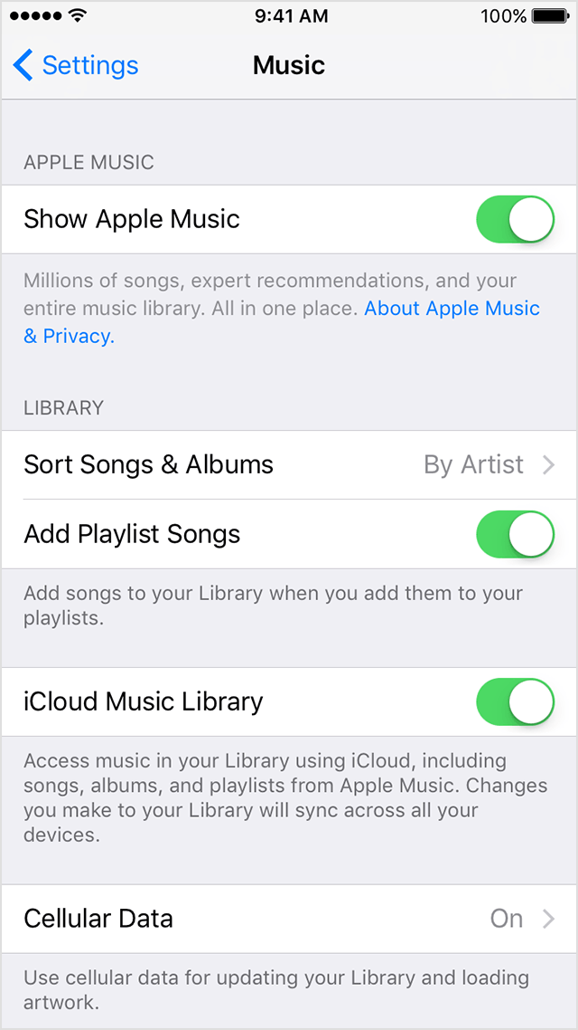
- If you already have music on your device, you're asked if you want to keep the music that's on your device.
- If you choose Keep Music*, the music from your device adds to your iCloud Music Library.
- If you choose Delete & Replace, the music on your device is replaced with the content from your iCloud Music Library.
On your Mac or PC
- Mac: From the menu bar at the top of your computer screen, choose iTunes > Preferences.
- 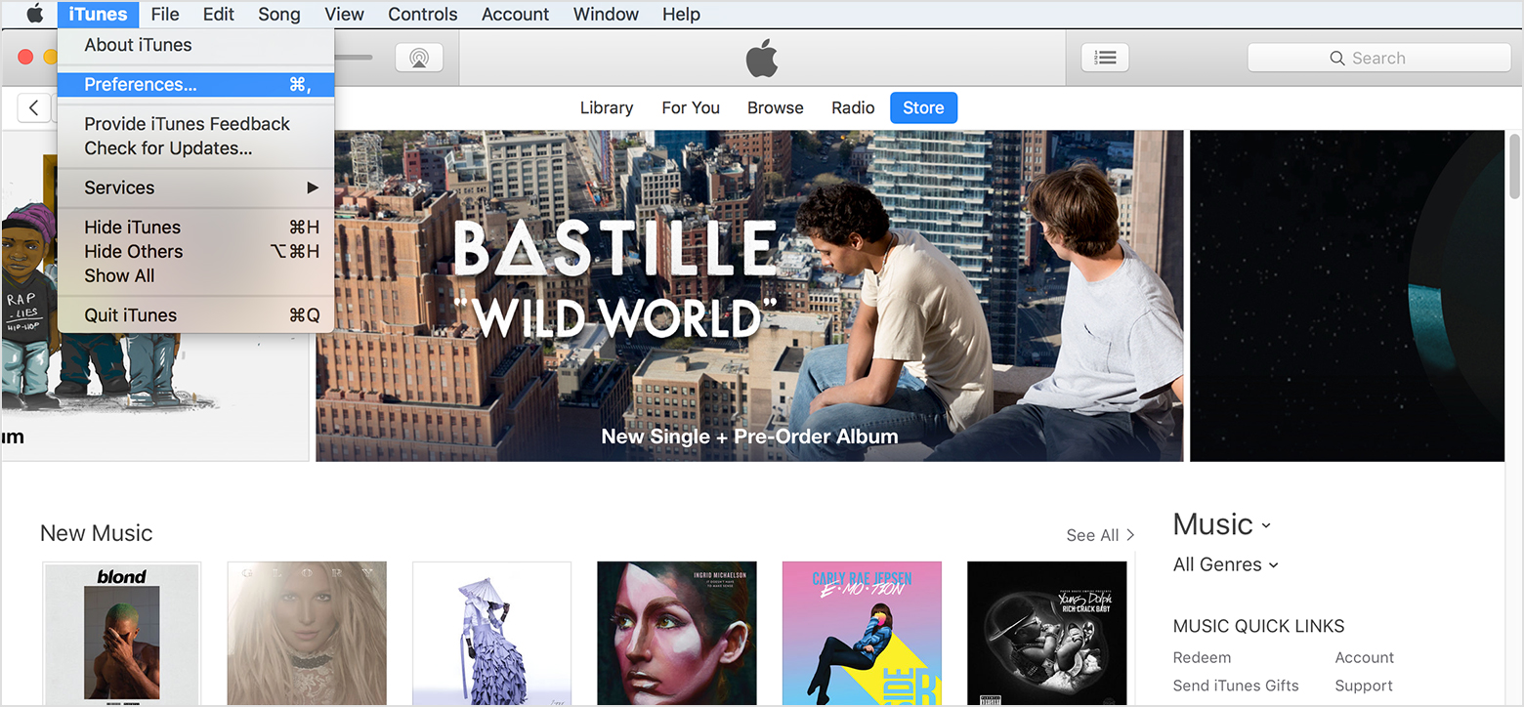

- Windows: From the menu bar at the top of the iTunes window, choose Edit > Preferences.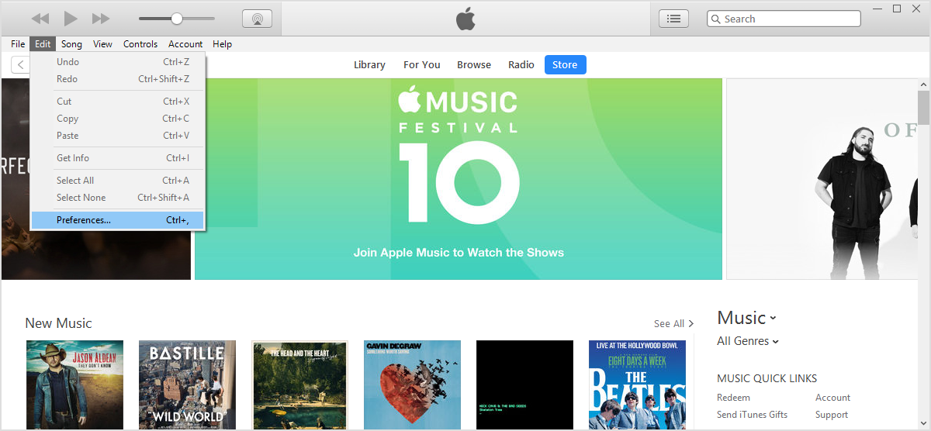
- Select iCloud Music Library to turn it on.
- 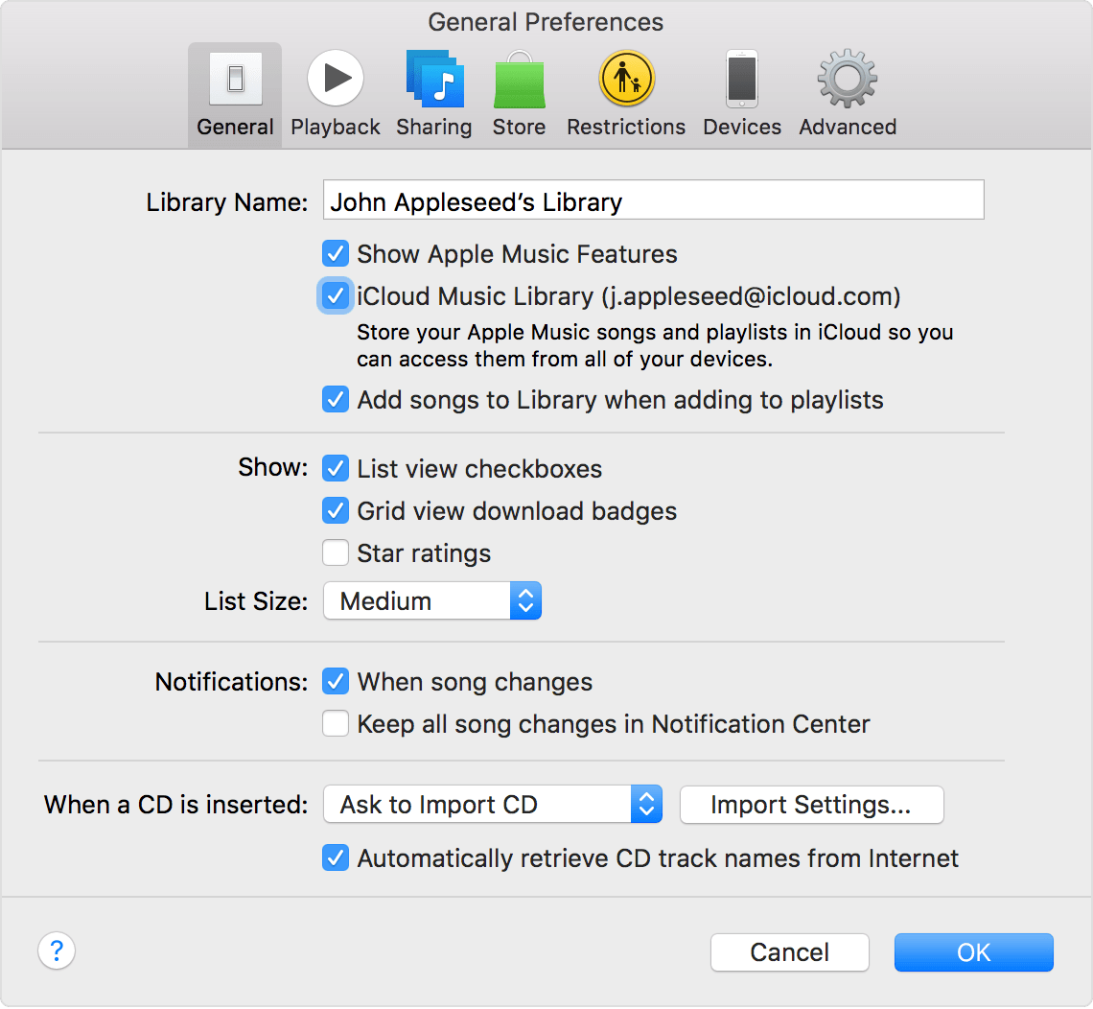
- Click OK.

If you don't see your content on all of your devices
On the computer that contains your original music library, make sure that you're signed in to iTunes with the Apple ID that you use for your Apple Music membership and have iCloud Music Library turned on. Then, from the menu bar at the top of your computer screen or the top of the iTunes window, choose File > Library > Update iCloud Music Library.

Learn more
If you're not an Apple Music member, learn the best way to get your music on all of your devices.

*When you choose Merge, songs on your device that are in the Apple Music catalog become instantly available to access on your other devices. On iPhone, iPad, and iPod touch, songs that we can’t match are shown on your other devices. But you won’t be able to play them on your other devices until you upload them from your Mac or PC with iTunes.
Information about products not manufactured by Apple, or independent websites not controlled or tested by Apple, is provided without recommendation or endorsement. Apple assumes no responsibility with regard to the selection, performance, or use of third-party websites or products. Apple makes no representations regarding third-party website accuracy or reliability. Risks are inherent in the use of the Internet. Contact the vendor for additional information. Other company and product names may be trademarks of their respective owners.
Helpful?
Yes No
Article:
HT204926
Last Modified:
03/18/2017
Radar Number:
29323214, 28281781, 27177776, 23050753 View >
Open tickets in radar
Affected Products:
iCloud

Related
How To
- iTunes for Mac: Use your iCloud Music Library to access all your music anytime, anywhere iTunes for Windows: Use your iCloud Music Library to access all your music anytime, anywhere About iCloud Music Library icons and status iOS 8 version history Access your music collection on all of your devices with Apple Music Add and download music from the Apple Music catalog to your Library Subscribe to iTunes Match Create and manage your music collection in Apple Music on Android
Procedures
SOP: iTunes Store: Handling Requests to Associate a Device with a Different Apple ID

