Sp722 public art w links to other phones iPhone 6s Plus Technical Specifications
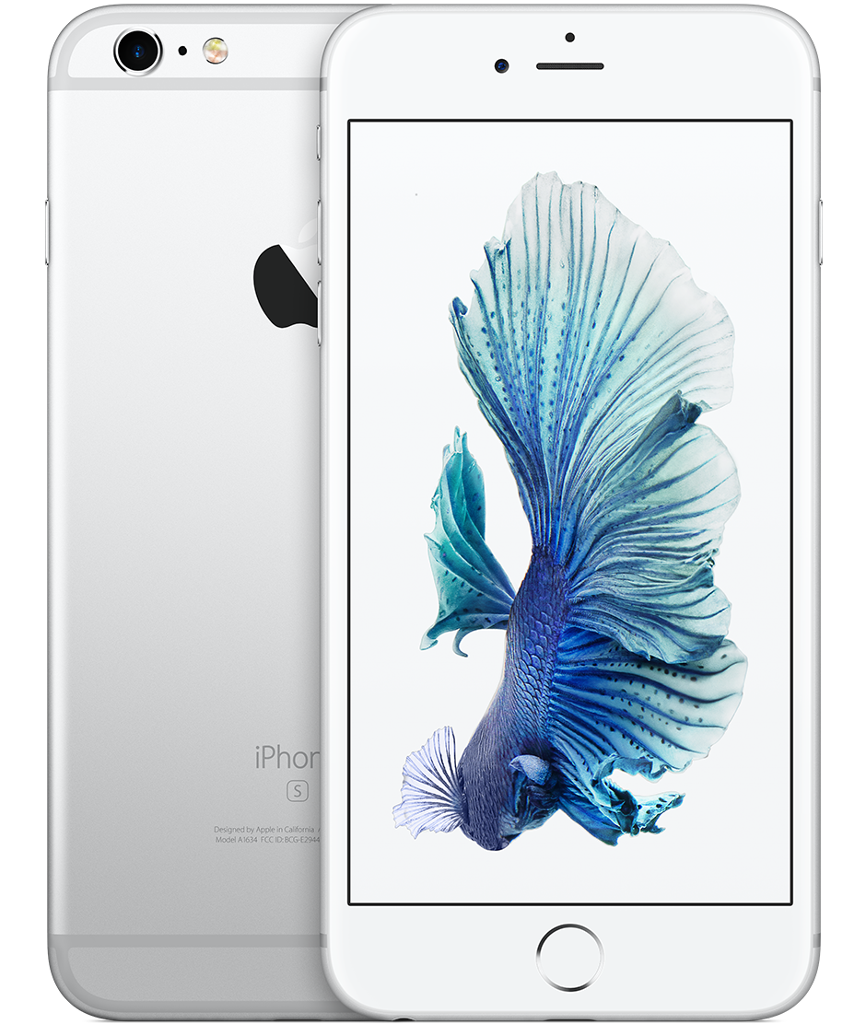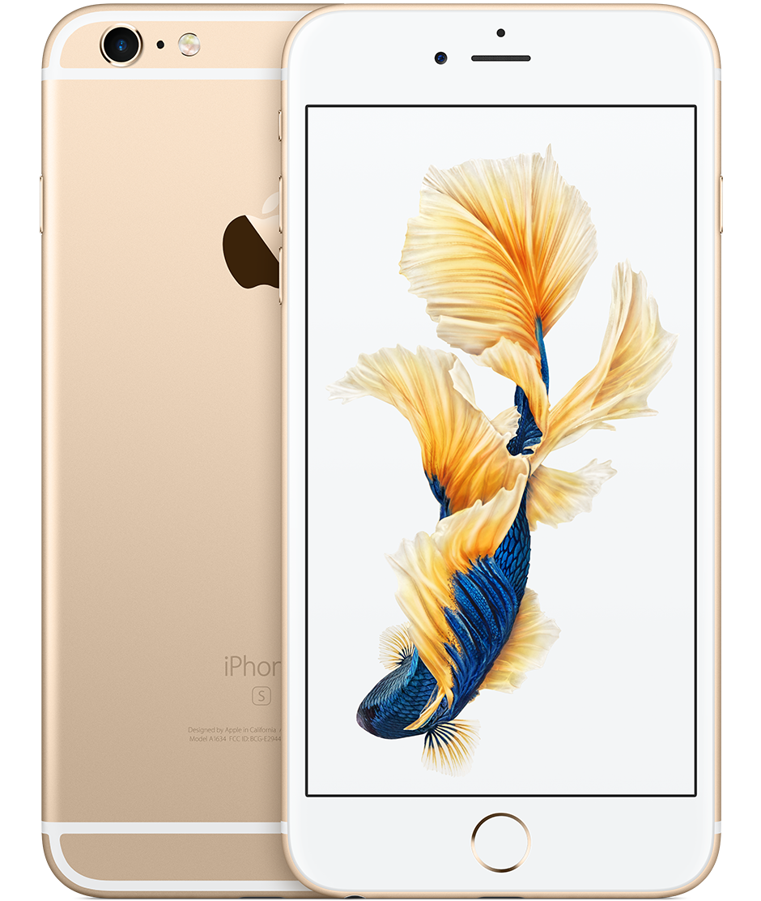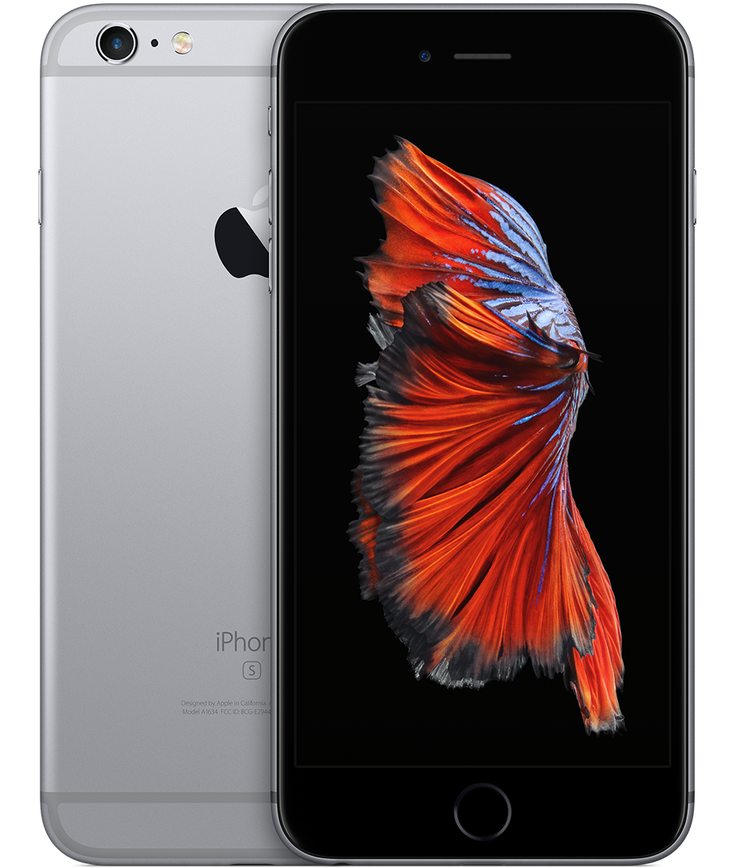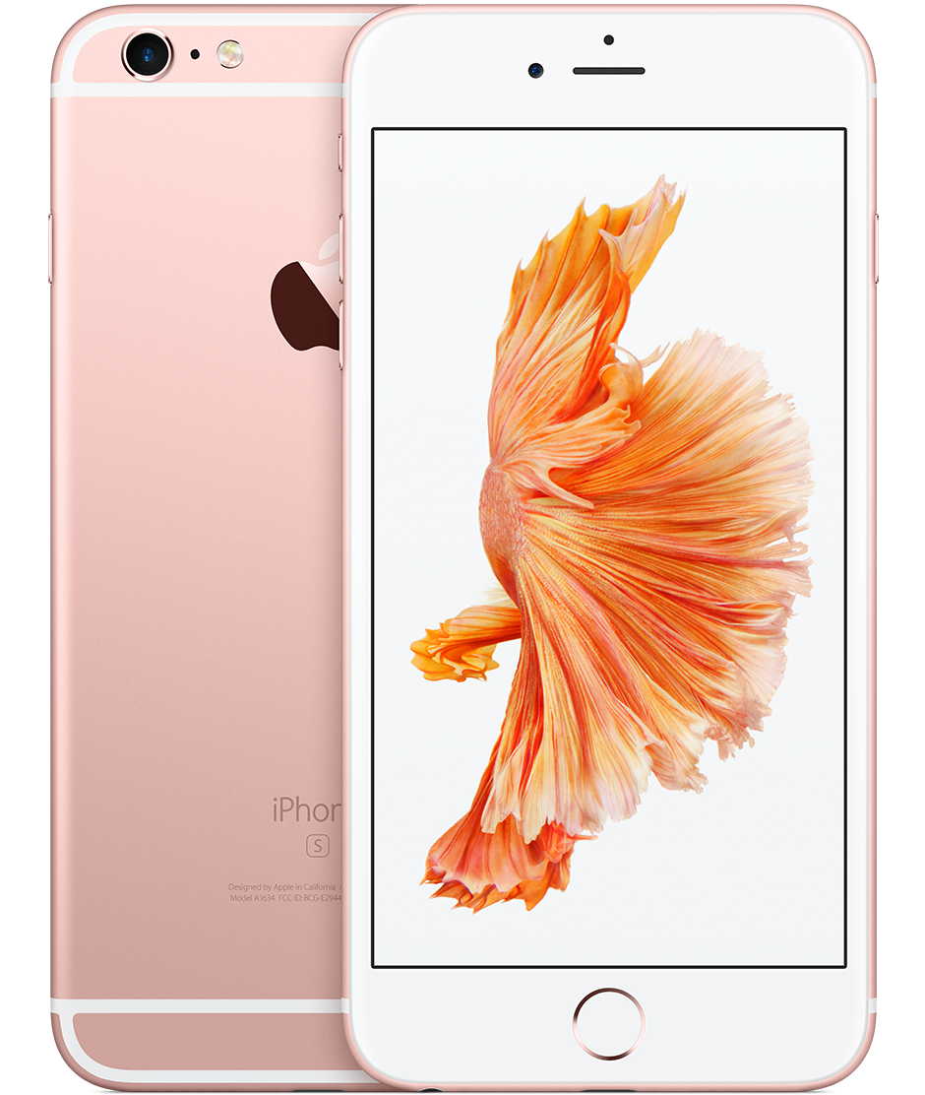

Finish
- Silver
- Gold
- Space Gray
- Rose Gold
Capacity¹
- 16GB
- 32GB
- 64GB
- 128GB
Size and Weight²
- Height: 6.23 inches (158.2 mm)
- Width: 3.07 inches (77.9 mm)
- Depth: 0.29 inch (7.3 mm)
- Weight: 6.77 ounces (192 grams)
Display
- Retina HD display with 3D Touch
- 5.5-inch (diagonal) LED-backlit widescreen
- Multi-Touch display with IPS technology
- 1920-by-1080-pixel resolution at 401 ppi
- 1300:1 contrast ratio (typical)
- 500 cd/m2 max brightness (typical)
- Full sRGB standard
- Dual-domain pixels for wide viewing angles
- Fingerprint-resistant oleophobic coating on front
- Support for display of multiple languages and characters simultaneously
- Display Zoom
- Reachability
Chip
- A9 chip with 64-bit architecture
- Embedded M9 motion coprocessor
Camera
- 12-megapixel camera
- Live Photos with stabilization
- Autofocus with Focus Pixels
- Optical image stabilization (iPhone 6s Plus only)
- True Tone flash
- Panorama (up to 63 megapixels)
- Auto HDR for photos
- Exposure control
- Burst mode
- Timer mode
- ƒ/2.2 aperture
- Five-element lens
- 5x digital zoom
- Hybrid IR filter
- Backside illumination sensor
- Sapphire crystal lens cover
- Auto image stabilization
- Local tone mapping
- Noise reduction
- Face detection
- Photo geotagging
Video Recording
- 4K video recording at 30 fps
- 1080p HD video recording at 30 fps or 60 fps
- 720p HD video recording at 30 fps
- Optical image stabilization for video (iPhone 6s Plus only)
- True Tone flash
- Slo-mo video support for 1080p at 120 fps and 720p at 240 fps
- Time-lapse video with stabilization
- Cinematic video stabilization (1080p and 720p)
- Continuous autofocus video
- Noise reduction
- Take 8-megapixel still photos while recording 4K video
- Playback zoom
- 3x digital zoom
- Face detection
- Video geotagging
FaceTime HD Camera
- 5-megapixel photos
- 720p HD video recording
- Retina Flash
- ƒ/2.2 aperture
- Auto HDR for photos and videos
- Backside illumination sensor
- Exposure control
- Burst mode
- Timer mode
- Face detection
Touch ID
- Fingerprint sensor built into the Home button
Apple Pay
- Pay with your iPhone using Touch ID in stores, within apps, and on the web
- Complete purchases made with Apple Pay on your Mac
- Receive and redeem rewards using rewards cards
Learn more about Apple Pay
Cellular and Wireless
- Model A1634*
- LTE (Bands 1, 2, 3, 4, 5, 7, 8, 12, 13, 17, 18, 19, 20, 25, 26, 27, 28, 29, 30)
- TD-LTE (Bands 38, 39, 40, 41)
- TD-SCDMA 1900 (F), 2000 (A)
- UMTS/HSPA+/DC-HSDPA (850, 900, 1700/2100, 1900, 2100 MHz)
- CDMA EV-DO Rev. A (800, 1700/2100, 1900, 2100 MHz)
- GSM/EDGE (850, 900, 1800, 1900 MHz)
- Model A1687*
- LTE (Bands 1, 2, 3, 4, 5, 7, 8, 12, 13, 17, 18, 19, 20, 25, 26, 27, 28, 29)
- TD-LTE (Bands 38, 39, 40, 41)
- TD-SCDMA 1900 (F), 2000 (A)
- CDMA EV-DO Rev. A (800, 1700/2100, 1900, 2100 MHz)
- UMTS/HSPA+/DC-HSDPA (850, 900, 1700/2100, 1900, 2100 MHz)
- GSM/EDGE (850, 900, 1800, 1900 MHz)
- All models
- 802.11a/b/g/n/ac Wi-Fi with MIMO
- Bluetooth 4.2 wireless technology
- NFC
Location
- Assisted GPS and GLONASS
- Digital compass
- Wi-Fi
- Cellular
- iBeacon microlocation
Video Calling³
- FaceTime video calling over Wi-Fi or cellular
Audio Calling³
- FaceTime audio
- Voice over LTE (VoLTE)⁴
- Wi-Fi calling⁴
Audio Playback
- Audio formats supported: AAC (8 to 320 Kbps), Protected AAC (from iTunes Store), HE-AAC, MP3 (8 to 320 Kbps), MP3 VBR, Dolby Digital (AC-3), Dolby Digital Plus (E-AC-3), Audible (formats 2, 3, 4, Audible Enhanced Audio, AAX, and AAX+), Apple Lossless, AIFF, and WAV
- User-configurable maximum volume limit
TV and Video
- AirPlay Mirroring, photos, audio, and video out to Apple TV (2nd generation or later)
- Video mirroring and video out support: Up to 1080p through Lightning Digital AV Adapter and Lightning to VGA Adapter (adapters sold separately)
- Video formats supported: H.264 video up to 4K, 30 frames per second, High Profile level 4.2 with AAC-LC audio up to 160 Kbps, 48kHz, stereo audio or Dolby Audio up to 1008 Kbps, 48kHz, stereo or multichannel audio, in .m4v, .mp4, and .mov file formats; MPEG-4 video up to 2.5 Mbps, 640 by 480 pixels, 30 frames per second, Simple Profile with AAC-LC audio up to 160 Kbps per channel, 48kHz, stereo audio or Dolby Audio up to 1008 Kbps, 48kHz, stereo or multichannel audio, in .m4v, .mp4, and .mov file formats; Motion JPEG (M-JPEG) up to 35 Mbps, 1280 by 720 pixels, 30 frames per second, audio in ulaw, PCM stereo audio in .avi file format
Siri⁵
- Use your voice to send messages, set reminders, and more
- Get proactive suggestions
- Use hands-free
- Listen and identify songs
Learn more about Siri
External Buttons and Connectors
- Touch ID sensor
- Volume up/down
- Ring/Silent
- On/Off - Sleep/Wake
- 3.5 mm headphone jack
- Lightning connector
- Microphones
- Built-in speaker
Power and Battery⁶
- Talk time (wireless): Up to 24 hours on 3G
- Internet use: Up to 12 hours on 3G, up to 12 hours on LTE, up to 12 hours on Wi-Fi
- HD video playback: Up to 14 hours
- Audio playback: Up to 80 hours
- Standby time: Up to 16 days
- Built-in rechargeable lithium-ion battery
- Charging via USB to computer system or power adapter
Sensors
- Touch ID fingerprint sensor
- Barometer
- Three-axis gyro
- Accelerometer
- Proximity sensor
- Ambient light sensor
Operating System
iOS 10
With an all-new design and all-new features, iOS 10 is the world’s most advanced mobile OS. It brings your iPhone to life in more intelligent and expressive ways than ever.
See what’s new in iOS 10
iOS 10 includes:
- AirDrop
- AirPlay
- AirPrint
- Control Center
- Handoff
- HomeKit
- iCloud
- iCloud Keychain
- Multitasking
- Night Shift
- Notification Center
- Siri
- Spotlight Search
Accessibility
Accessibility features help people with disabilities get the most out of their new iPhone 6s. With built-in support for vision, hearing, physical and motor skills, and learning and literacy, you can fully enjoy the world’s most personal device. Learn more
Features include:
- VoiceOver
- Zoom
- Magnifier
- Software TTY
- Siri and Dictation
- Switch Control
- Closed Captions
- AssistiveTouch
- Speak Screen
Built-in Apps
Built-in apps are an essential part of your iPhone experience and are efficiently designed to use less than 200MB of storage.
- Camera
- Photos
- Health
- Messages
- Phone
- FaceTime
- Mail
- Music
- Wallet
- Safari
- Maps
- Siri
- Calendar
- iTunes Store
- App Store
- Notes
- News
- Contacts
- iBooks
- Home
- Weather
- Reminders
- Clock
- Stocks
- Calculator
- Voice Memos
- Compass
- Podcasts
- Watch
- Tips
- iCloud Drive
- Find My iPhone
- Find My Friends
- Settings
Free Apps from Apple⁷
Pages, Numbers, Keynote, iMovie, GarageBand, and iTunes U are preinstalled on iPhone models with a capacity of 32GB or higher.
- iMovie
- Pages
- Keynote
- Numbers
- iTunes U
- GarageBand
- Apple Store
- Trailers
- Apple TV Remote
- iTunes Remote
- Music Memos
- Clips
Headphones
- EarPods with 3.5 mm Headphone Plug
- Storage and travel case
SIM Card
- Nano-SIM
- iPhone 6s and iPhone 6s Plus are not compatible with existing micro-SIM cards.
Rating for Hearing Aids
- iPhone 6s Plus (Model A1634, A1687): M3, T4
Mail Attachment Support
- Viewable document types
- .jpg, .tiff, .gif (images); .doc and .docx (Microsoft Word); .htm and .html (web pages); .key (Keynote); .numbers (Numbers); .pages (Pages); .pdf (Preview and Adobe Acrobat); .ppt and .pptx (Microsoft PowerPoint); .txt (text); .rtf (rich text format); .vcf (contact information); .xls and .xlsx (Microsoft Excel); .zip; .ics
System Requirements
- Apple ID (required for some features)
- Internet access⁸
Syncing with iTunes on a Mac or PC requires:
- Mac: OS X 10.9.5 or later
- PC: Windows 7 or later
- iTunes 12.5 or later (free download from www.itunes.com/download)
Environmental Requirements
- Operating ambient temperature: 32° to 95° F (0° to 35° C)
- Nonoperating temperature: -4° to 113° F (-20° to 45° C)
- Relative humidity: 5% to 95% noncondensing
- Operating altitude: tested up to 10,000 feet (3000 m)
Languages
- Language support
- English (Australia, Canada, UK, U.S.), Chinese (Simplified, Traditional, Traditional Hong Kong), French (Canada, France), German, Italian, Japanese, Korean, Spanish (Latin America, Mexico, Spain), Arabic, Catalan, Croatian, Czech, Danish, Dutch, Finnish, Greek, Hebrew, Hindi, Hungarian, Indonesian, Malay, Norwegian, Polish, Portuguese (Brazil, Portugal), Romanian, Russian, Slovak, Swedish, Thai, Turkish, Ukrainian, Vietnamese
- QuickType keyboard support
- English (Australia, Canada, India, Singapore, UK, U.S.), Chinese - Simplified (Handwriting, Pinyin, Stroke), Chinese - Traditional (Cangjie, Handwriting, Pinyin, Stroke, Sucheng, Zhuyin), French (Belgium, Canada, France, Switzerland), German (Austria, Germany, Switzerland), Italian, Japanese (Kana, Romaji), Korean, Spanish (Latin America, Mexico, Spain), Arabic, Bengali, Bulgarian, Catalan, Cherokee, Croatian, Czech, Danish, Dutch, Emoji, Estonian, Filipino, Finnish, Flemish, Greek, Gujarati, Hawaiian, Hebrew, Hindi (Devanagari, Transliteration), Hinglish, Hungarian, Icelandic, Indonesian, Latvian, Lithuanian, Macedonian, Malay, Marathi, Norwegian, Polish, Portuguese (Brazil, Portugal), Punjabi, Romanian, Russian, Serbian (Cyrillic, Latin), Slovak, Slovenian, Swedish, Tamil (Script, Transliteration), Telugu, Thai, Turkish, Ukrainian, Urdu, Vietnamese
- QuickType keyboard support with predictive input⁹
- English (Australia, Canada, India, Singapore, UK, U.S.), Chinese (Simplified, Traditional), French (Belgium, Canada, France, Switzerland), German (Austria, Germany, Switzerland), Italian, Japanese, Korean, Russian, Spanish (Latin America, Mexico, Spain), Portuguese (Brazil, Portugal), Thai, Turkish
- Siri languages
- English (Australia, Canada, India, Ireland, New Zealand, Singapore, South Africa, UK, U.S.), Spanish (Chile, Mexico, Spain, U.S.), French (Belgium, Canada, France, Switzerland), German (Austria, Germany, Switzerland), Italian (Italy, Switzerland), Japanese, Korean, Mandarin (Mainland China, Taiwan), Cantonese (Mainland China, Hong Kong), Arabic (Saudi Arabia, United Arab Emirates), Danish (Denmark), Dutch (Belgium, Netherlands), Finnish (Finland), Hebrew (Israel), Malay (Malaysia), Norwegian (Norway), Russian (Russia), Swedish (Sweden), Turkish (Turkey), Thai (Thailand), Portuguese (Brazil)
- Dictation languages
- English (Australia, Canada, India, Ireland, Malaysia, New Zealand, Philippines, Saudi Arabia, Singapore, South Africa, UAE, UK, U.S.), Spanish (Chile, Colombia, Mexico, Spain, U.S.), French (Belgium, Canada, France, Luxembourg, Switzerland), German (Austria, Germany, Luxembourg, Switzerland), Italian (Italy, Switzerland), Japanese, Korean, Mandarin (Mainland China, Taiwan), Cantonese (Hong Kong), Arabic (Kuwait, Saudi Arabia, Qatar, UAE), Catalan, Croatian, Czech, Danish, Dutch (Belgium, Netherlands), Finnish, Greek, Hebrew, Hungarian, Indonesian, Malaysian, Norwegian, Polish, Portuguese (Brazil, Portugal), Romanian, Russian, Slovakian, Swedish, Turkish, Thai, Ukrainian, Vietnamese
- Definition dictionary support
- English, Chinese (Simplified, Traditional), Danish, Dutch, French, German, Hindi, Italian, Japanese, Korean, Norwegian, Portuguese (Brazil), Russian, Spanish, Swedish, Thai, Turkish
- Bilingual dictionary support
- Chinese (Simplified), Dutch, French, German, Italian, Japanese, Korean, Spanish
- Spell check
- English (Australia, Canada, UK, U.S.), French, German, Italian, Spanish, Danish, Dutch, Finnish, Korean, Norwegian, Polish, Portuguese (Brazil, Portugal), Russian, Swedish, Turkish
In the Box
- iPhone with iOS 10
- EarPods with 3.5 mm Headphone Plug
- Lightning to USB Cable
- USB Power Adapter
- Documentation
iPhone and the Environment
Apple takes a complete product life cycle approach to determining our environmental impact. Learn more
iPhone 6s and iPhone 6s Plus embody Apple’s continuing environmental progress. They are designed with the following features to reduce environmental impact:
- Mercury-free LED-backlit display
- Arsenic-free display glass
- Brominated flame retardant–free
- PVC-free
- Beryllium-free
- Recyclable aluminum enclosure
- Power adapter outperforms strictest global energy efficiency standards
- Speaker enclosure with 30 percent post-consumer recycled plastic
Apple and the Environment
Learn more about Apple’s dedication to reducing the environmental impact of our products and process. Or read our Product Environmental Reports for detailed information on the environmental performance of every Apple product.
Recycling
Apple takes a holistic view of materials management and waste minimization.
Learn more about how to recycle your iPhone

* To identify your iPhone model number, see http://support.apple.com/kb/HT3939. For details on LTE support, contact your carrier and see www.apple.com/iphone/LTE. Cellular technology support is based on iPhone model number and configuration for either CDMA or GSM networks.
- Available space is less and varies due to many factors. A standard configuration uses approximately 4GB to 6GB of space (including iOS and built-in apps) depending on the model and settings.
- Size and weight vary by configuration and manufacturing process.
- FaceTime calling requires a FaceTime-enabled device for the caller and recipient and a Wi-Fi connection. Availability over a cellular network depends on carrier policies; data charges may apply.
- Data plan required. LTE Advanced, LTE, VoLTE, and Wi-Fi calling are available in select markets and through select carriers. Speeds are based on theoretical throughput and vary based on site conditions and carrier. For details on LTE support, contact your carrier and see www.apple.com/iphone/LTE.
- Siri may not be available in all languages or in all areas, and features may vary by area. Internet access required. Cellular data charges may apply.
- All battery claims depend on network configuration and many other factors; actual results will vary. Battery has limited recharge cycles and may eventually need to be replaced by Apple service provider. Battery life and charge cycles vary by use and settings. See www.apple.com/batteries and www.apple.com/iphone/battery.html for more information.
- iMovie, GarageBand, Pages, Numbers, and Keynote are available on the App Store. Downloading apps requires an Apple ID and a device that is compatible with the iOS version required for each app.
- Wireless broadband recommended; fees may apply.
- Customized suggestions based on recipient and app are not available for Chinese (Simplified, Traditional), Japanese, Korean, and Thai.
Some features may not be available for all countries or all areas. Click here to see complete list.

Article:
SP727
Last Modified:
05/06/2017
Affected Products:
iPhone 6s Plus

Related
How To
- Beats Pill+ app system requirements for iOS devices Understanding iOS system requirements Get help using Continuity with your iOS device or your Mac iOS: System requirements for Personal Hotspot System requirements for iCloud
Specifications
iPhone 6s - Technical Specifications iPhone 7 Plus - Technical Specifications iPhone 6 Plus - Technical Specifications iPhone 6 - Technical Specifications

